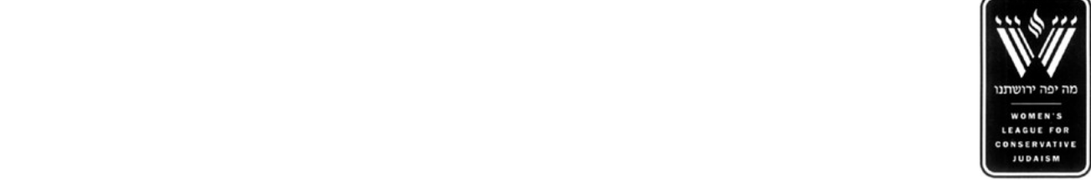Join Beth Shalom Sisterhood

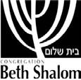

on November 9th for Bams for Mams!

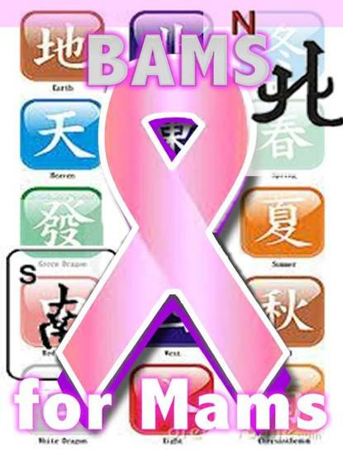

Thursday, Nov. 9th

Brunch 10:30 am

Game Time 11:00 am

Goldsmith Hall

*Non-Sisterhood friends welcome!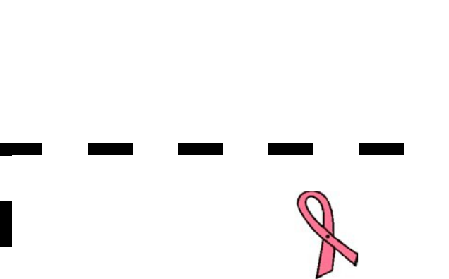

Play Mah Jongg

with your regular group

or be placed with a table

Have fun while raising money to support breast cancer research

Cost: $10 per person for brunch

and snacks payable to:

Beth Shalom Sisterhood

**And** $15 minimum donation

payable to: KU Breast Cancer Center

For more information, please contact

Carol Peltzie: cpeltzie1@gmail.com

913-449-1107





 Please mail checks by Wednesday, November 1st to:

Carol Peltzie, 14919 Brentwood Drive, Lenexa, KS 66215

 Name



Email Address  Phone Number

**Please remember to write 2 separate checks.**



I would love to join you for brunch ($10 per person – check payable to Beth Shalom Sisterhood)



I would like to play Mah Jongg (minimum $15 donation - payable to KU Breast Cancer Center)



____I am coming with a Mah Jongg group. Write names on back.



____I would like to play Mah Jongg but need to be placed with a table.

I will be happy to bring:

a card table a Mah Jongg set an extra Mah Jongg card

