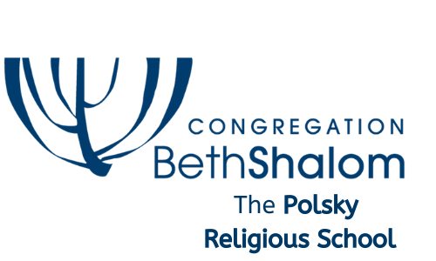
Family Handbook

14200 Lamar Avenue
Overland Park, KS 66223
http://www.bethshalomkc.org/

School Telephones: 913-647-7279 (office main line)
913-647-7282 (Civia’s Desk)
816-609-8445 (Civia’s cell)

E-mail addresses: cwhite@bethshalomkc.org

MISSION
The Polsky Religious School of Conservative Judaism will create an inclusive religious school environment for children and their families that fosters a life-long love of Jewish learning, Jewish identity, and spiritual growth in accordance with the philosophy of the Conservative Movement.

VISION
We foster family commitment to the study of Torah, worship and performing mitzvot within a caring community.

VALUES
The Polsky Religious School of Conservative Judaism demonstrates values of “Al sh’loshah d’varim haolam omed: al haTorah; al haAvodah; v’al G’milut Hasadim.” “The world is founded on three things: on study; on worship; and on acts of loving kindness.” Pirket Avot—Ethics of the Fathers, 1:2.

Our Why…

The Polsky Religious School of Congregation Beth Shalom differentiates itself from other schools in the Kansas City area in several ways.
At the Polsky Religious School, your child will not only learn the Hebrew he or she needs to prepare to read Torah, Haftarah and lead at least the Torah service. In our school, we cultivate a deep connection to the Hebrew language - a love of Hebrew. While we do not have the teaching hours required for our students to become fluent Hebrew-speakers, they leave the Polsky Religious School wanting to learn more, and with the passion to continue to learn Hebrew and connect with Hebrew-speakers in college and beyond.
Our students develop a deep connection to Israel. From this place of love and care for Israel and her people, the Polsky Religious School students have the tools to grapple with the difficult issues that face Israel and her people, and honest conversations about those issues are encouraged and facilitated by our faculty as well as clergy in the upper grades
One of the core tenets of the The Polsky Religious School is to give our students the skills they require to participate fully in Jewish life once they leave home.
Every Sunday morning, our grade-level learning is enriched with community t’fillah, prayer, where students assist in leading services from the youngest age. We eat breakfast together, participate in services together, and then enjoy a mashal – a story with a lesson – together. Each story teaches us something about ourselves and about our history, and each story is a ruby in the crown of Jewish learning.
Throughout the year, there will be several opportunities for your entire family to engage with Beth Shalom through the Polsky Religious School-related events. You will be invited to purely social events as well as events connected to holidays or to Shabbat. I hope you will attend these events with your friends, as they serve to bring our community closer, to foster meaningful, lasting friendships within our Beth Shalom community.
The Polsky Religious School faculty is committed to nurturing the Jewish soul of each child, supporting the learning of every student and family. We are an inclusive, caring school community, and we are very glad you have chosen the Polsky Religious School. We look forward to an amazing school year together with your family!

Sunday Programs
Sunday at 9 am

9 am Family Breakfast - All Ages
9:30 am Family Services - All Ages
10 am Classes by Grade

- Pre-K monthly
- Kindergarten
- 1st Grade
- 2nd Grade
- 3rd-Grade
- 4th and 5th Grades
- 6th,7th and 8th Grades
- High School Students are Madrichim (classroom assistants)
The pick-up time is Noon.

Wednesday Programs

3:15 pm Homework Hall (optional) Supervised early arrival in Goldsmith Hall. Hebrew tutoring is available.

4:15 pm Hazzan leads practice Torah service
4:30 pm to 6:15 pm
- 3rd-7th Grades

Pick-up time is 6:15 pm.

SUNDAY MORNING TEFILLOT: Every Sunday, grades K-8 and parents begin in the Goldsmith Hall with community tefillot, davening and prayer time. Hazzan Ben-Yehuda will lead the service, and students will participate in the learner’s minyan, a special service designed for our students to experience prayer, learn the prayers and have an opportunity to lead the prayers they have learned. Teachers and madrichim will be present for tefillot.

Conduct
We expect that all students and adults will honor themselves, synagogue property, teachers and classmates with respectful and appropriate behavior. We ask that our parents partner with us to talk to your student about how to be a positive influence in our community. Bullying is not tolerated whatsoever. We take this behavior very seriously and provide the following strategic plan for such behavior. If a student is bullying or causing anyone to feel unsafe in the classroom the following will happen:
- The student will be removed from class and brought to the office.
- The office will call the student’s parents.
- If a student uses physical violence, the student will be sent home and parents will need to meet shortly thereafter with the Director of Education to discuss and understand the incident and decide on a strategic plan for the students involved.

Procedures for Leaving the Campus
While classes or programs are in session, students are not allowed to leave the building unless accompanied by a parent/guardian, or on an officially sanctioned field trip.

If it is necessary to take your child out of school early, please come into the school office and sign the student(s) out.
Teachers have been instructed to never dismiss a student from class without first being notified to do so from the office.

Visitor Regulations, Snow and Other Emergency Information
Visiting Parents
Parents are welcome to visit the The Polsky Religious School. If you want to visit during school hours, let us know in advance. Please sign in at the office so that we know who is in the building and can inform the appropriate teacher or teachers.
School Closing Information
The Polsky Religious School will close due to inclement weather or if road conditions are unsafe. We follow the Blue Valley School System; if they call a snow day, there will be no Hebrew School that day.
Please check one of the following if you are unsure.

- Check the Beth Shalom website www.bethshalomkc.org
- Check the Beth Shalom Facebook page https://www.facebook.com/BethShalomKC
- Text Civia at 816 609 8445

KASHRUT POLICY AT BETH SHALOM
In this space Kashrut refers to the body of Jewish religious laws concerning the suitability of food. Since many of our Wednesday students come to Beth Shalom after a long day of public/private school and other activities, we know that they will often bring snacks with them to have before the beginning of classes. In order to make sure that the Kashrut standards of the Synagogue are maintained, here is a brief list of kashrut symbols to help you determine if a snack is kosher. Should you have any questions regarding this subject, please direct them to Hazzan Ben-Yehuda or to Rabbi Glickman. Thank you for your cooperation.

NOTE: WE ARE A NUT FREE SCHOOL. PLEASE REMEMBER TO SELECT SNACKS THAT DO NOT CONTAIN NUTS OR NUT PRODUCTS.

Only snacks with a Kashrut symbol may be brought into the building--e.g.
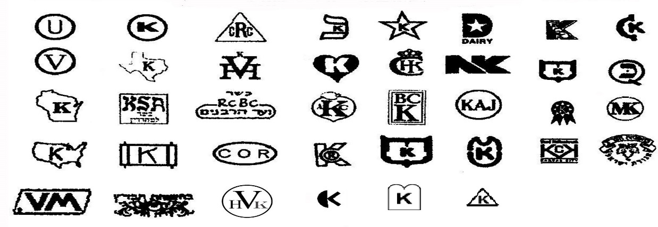

Some of the more common acceptable snack products are as follows:

Sunshine & Nabisco cookies Sarah Lee cookies
Twizzlers licorice Bachman pretzels
Jelly Belly jellybeans Snyders pretzels
Pepperidge Farm cookies Soda & juice (all flavors except grape)
Entenmann's Hershey Products
Girl Scout cookies Paskesz cookies & candy
Orville Redenbacker popcorn Mars candy products
Pringles Ruffles Chips
Pop Secret popcorn

Hard cheeses do not need to have a heksher as long as they contain no prohibitive ingredients. Processed cheeses may be used within the synagogue as long as no meat or non-kosher additives are contained within those cheeses

In addition, the following bakeries in our community are under rabbinic supervision:

Hen House Bakery (117th & Roe only) Meshuggah Bagels (7096 W. 105th St.)

WEDNESDAY SNACKS There will be a 10 minute break between classes for students to eat a snack from home or to select from a limited choice of packaged foods provided by PRS.

Birthday Treats
If you wish to have your child's birthday celebrated at school, please speak with the classroom teacher at least two weeks in advance to arrange for the proper treats. We will be happy to assist you in selecting an appropriate kosher snack.
The Polsky Religious School strives to provide a safe learning environment for all our students as we integrate the ages-old tradition of seudat mitzvah, a meal celebrating the performance of a mitzvah, into many of our holiday celebrations. Frequently, traditional foods are served as part of school lessons/celebrations. If a child has a food allergy, it is essential that parents inform the school office on their health form. In addition, parents should brief their child’s teacher as to the implications of the food allergy.

Children who might require the use of an epi pen due to allergies should be sure to carry one with them at all times. We suggest an epi-pen (labeled with your child’s name) be kept in the Religious School Coordinator’s office. Teachers will be trained to administer them at the beginning of each school year.

Administrative Policies & Procedures

Absences
If you know your child will be absent from Polsky Religious School, please email cwhite@bethshalomkc.org and your child’s teacher to let us know that your child will not be in class that day.

Accommodations and Support for children in the classroom
Thanks to the generous support the Jewish Federation, the Sasone Fund enables children in our school who need accommodations and support receive the help they need so that all of our children learn together, so that our community includes everyone.
If your child needs accommodations or any type of support, please speak with Laura Galler, our Sasone Specialist, so that she can understand your child’s needs, and can pair your child with a para who will assist your child.

Alcohol/Drug/Illegal Substance Policy
The Polsky Religious School strives to create a safe and healthy environment that fosters learning with a full mind, body, and soul present. Therefore we have a zero tolerance policy on alcohol, drugs and illegal substances.
If there is a reasonable suspicion that a student has used, or is in the possession of one of the substances or paraphernalia referenced above, the Director of Congregational Learning will remove the student from the class or program, and a parent conference with the Director will take place before that student can return.
Books/Materials
Each child will receive the necessary text materials for their class, which will be checked out to him/her. It is the student's responsibility to make sure the non-consumable materials are returned at the end of the year in (as close to) the same condition as they were received. Some of these materials will be consumable and will be sent home when they are completed or at the end of the year. If a student is unable to locate his/her books for two consecutive sessions, it is our policy to assume the materials are lost. We will re-order them and bill you accordingly. Any other materials that are defaced or damaged in any way, will also be billed to you. Please encourage your children to take care of and respect school property.

Help keep our school green—send a non-disposable water bottle to school with each of your children to keep in their desks.

Cell Phones
This policy was approved by the The Polsky Religious School committee. The Polsky Religious School is not responsible for any cell phones or electronic devices that are brought to school.
- During school hours, cell phones and other electronic devices are to be turned off and kept out of sight.
- Any phone or electronic device that is visible will be taken from the student and returned at the end of class (unless below #4 is applied).
- There are land-line telephones in each classroom that teachers can use in case of emergency, and that the office can use to contact a teacher during class.
- In older grades, it is possible that students may be asked by the teacher to use their smart phone during class during a lesson. This is the only exception to the cell phone rule.
We recognize that it is a parental decision whether your children should have a cell phone. Our policy is designed to enhance the safety and education of all our students. If a student needs to contact a parent or a parent needs to contact a student, this can be done through the school’s front desk (913-647-7290).

Dress Code
We ask that students dress appropriately for the place and purpose. When we pray, we speak to God. When we study, God speaks to us. Please dress appropriately as classes often begin in the sanctuary with a short service. Shoulders should be covered; short miniskirts, short shorts and inappropriate logos on t-shirts are not suitable for services.

Emergencies
If a child is injured while at The Polsky Religious School, we will take the appropriate means of intervention and parent(s) will be notified. In more serious cases, the parent will be notified immediately. For any injury in which we feel it is necessary for the child to have immediate emergency medical attention, the paramedics will be called to the school, and parents will be contacted.
Each child must have a current Consent for Emergency Treatment form on file in the school office. If there is a change in any of your child’s information, it is your responsibility to inform the office immediately.

Health & Safety
Good health is an integral part of a student's school experience. The Polsky Religious School follows public school policy; UNDER NO CIRCUMSTANCES SHOULD A SICK STUDENT BE BROUGHT TO SCHOOL.
- In addition to keeping your student out of school, please notify the school if your child contracts any infectious illnesses such as Covid, Chicken Pox, Strep Throat or head lice.
- In addition to keeping your student out of school, if your child has a fever or has vomited due to illness, please keep your child out of school for 24 hours.
- If your child is on antibiotics, please wait one full day to send him/her back to school.
- If someone in your family has tested positive for Covid, we will follow the health department guidelines on welcoming your child back to class.
- If a student in the Polsky Religious School tests positive for Covid, we will likewise follow health department guidelines on informing the class of the illness. We will always act in the way that we understand will best guard the health and safety of all of our students, faculty and staff.
Homework
All students will engage in project work, and occasionally they will need time outside of class to prepare. Please support your children in their need to do research or preparations for any projects. When learning Hebrew, it is extremely important for some work to be done at home to facilitate retention and the development of skills. It is in your child's best interest to encourage Hebrew review for about ten minutes several times a week.
- We appreciate your cooperation in supporting the teachers by making sure that any assignments are completed when they are due.
Please consult your child’s teacher for clarification on class assignments.
Kipot & Tallitot
Appropriate synagogue garb is to be worn during Religious School classes and tefillot (prayers). The wearing of kipot is required for boys/young men and encouraged for girls/young women.
Passport to Israel
This community-wide, savings-incentive program provides matching money to 3rd through 8th graders through the Flo Harris Supporting Foundation. There are 2 ways to participate in this program.

The first way is beginning in the 3rd grade and through 8th grade, families can contribute $150, Beth Shalom contributes $50 and the Jewish Community Foundation will match this combined $200 with another $100 for a combined total of $300.
In the second option, Beth Shalom will increase its contribution from $50 to $100, families will increase their contributions from $150 to $200, and the Jewish Community Foundation will match this combined $300 with another $100 for a combined total of $400. In addition, Beth Shalom will open this program to second grade students. The Jewish Community will not participate in the second grade contribution, but will in all subsequent 3rd through 8th grade years.

Passport money may be used for approved Israel programs and March of the Living. The Beth Shalom deadline for turning in your contribution is November 29, 2021 — there will be no exceptions.

Scholarship Assistance
Religious School scholarship assistance is available for families who are members in good standing for one year prior to their application.
Beth Shalom families can obtain scholarship forms from the school office for both religious school and summer programs. They should be completed and returned to the school office, along with your most current W-4.
Keren Ami (Kayemet)
What was known in the program as “Tzedakah” is called “Keren Ami”. We are intentional with our use of Hebrew and “Keren Ami Kayemet” is money for needy people. Keren Ami will be collected at the start of each K-10 class. (One suggestion is that each child bring a zip lock bag with enough change for an entire month.) Teachers discuss the importance of Keren Ami Kayemet from the very first day of classes, and students are encouraged to participate in this mitzvah, as they are able. Throughout the year students will be encouraged to bring other items, such as blankets, clothes or toys to support Congregation or school-sponsored social action projects.

