

Beth Shalom’s
Rose Family
Early Childhood Education Center
2020-2021

Parent Policy Book

Director of Early Childhood Education
Judy Jacks Berman
913/647-7287
jjb@bethshalomkc.org

School Administrative Assistant
Debbie Beznovsky & Melisa Gum
rfec@bethshalomkc.org
913/647-7285

School Office Telephone: 913/647-7285
School Office Fax: 913/647-7278
Congregation Beth Shalom
Office Telephone: 913/647-7279
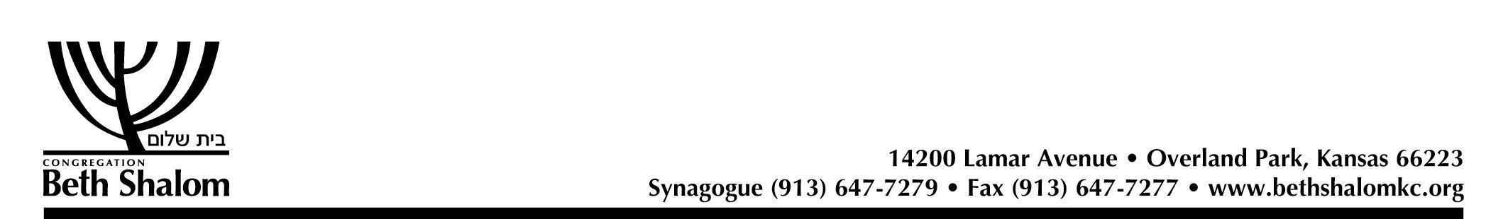
Table of Contents

Page 3 Message from Judy Jacks Berman, Director of Early Childhood Education

Page 4,5 Health & Safety

Page 6,7 Communicable Diseases

Page 8 Arrival & Departure; School Closing Policy

Page 9 Emergency Treatment; Discipline

Page 10, 11 Parking & Security Information

Page 11,12 Clothing

Page 13, 14 Birthday Parties; Kashrut Symbols

Page 15 Lunch Ideas



Dear Parents,

Beth Shalom Rose Family Early Childhood Education Center offers the best Jewish Early Childhood Education in town; a warm, nurturing, loving environment where children feel safe, secure and loved. They flourish in our environment while developing confidence and excitement for learning! Our children go into kindergarten very prepared and enthusiastic about school!

Our Pre-K offers a fabulous program and we have expanded on all the great activities that we currently offer. Expectations are being raised for incoming Kindergarteners. To meet the needs of the common core, we have raised the bar with new and creative curriculums in Handwriting, Literacy, Math and Science. Our 2020-2021 Pre-K program hours are 9:00 – 1:30 pm, Monday through Thursday and until 12:00 pm on Fridays.

Our 3 year old program challenges children to problem solve, share, explore their school environment and work together with their peers.

Our toddler and mini-school programs help children learn how to separate from their parents and transition to preschool with confidence. They learn how to participate in group activities and explore their many new school activities with independence and curiosity!

We are fortunate to have the finest preschool faculty in town. Our school has very little staff turnover, insuring a consistently outstanding program. In addition, we have very low teacher to child ratios and small class sizes. Our building, with an incredible state of the art playground, offers the finest facility in the area.

B’Shalom,

Judy Jacks Berman
Director of Early Childhood Education

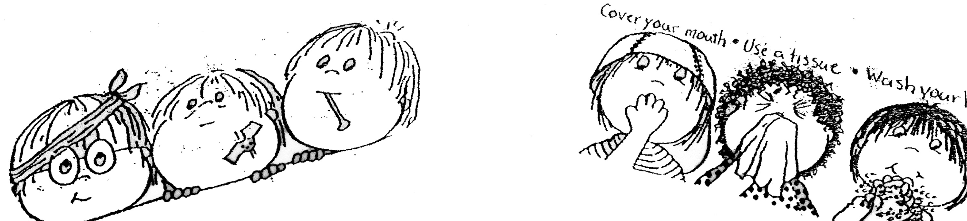
HEALTH AND SAFETY

1. If your child is unable to attend due to illness, please call the school
office at 913/647-7285.

2. Please keep children home if they exhibit any of the following
symptoms: Sore throat, skin rash, red inflamed eyes or eyes with
discharge, vomiting, diarrhea, severe cough, or swollen glands,
temperature of 99.6 degrees or greater orally within the last 24
hours, yellow or green discharge from the nose.
If your child is under the weather, please keep them home to keep everyone healthy.

3. Should your child come down with a communicable disease, please notify the office immediately. This way we can alert the other parents that they need to watch for symptoms.

4. If your child has been ill, he may return to school if he has been fever, vomit, and/or diarrhea free for 24 hours. Always be sure that your child is completely recovered before sending him back to school.

5. We will use ice packs on bruises and cut lips.

6. If your child needs prescription medication during school hours, please
fill out a medication form in the school office where it will be kept on file.
Medicine must be in the original container from the pharmacy.

7. Should your child become ill, or sustain an injury at school, you
will be notified immediately. Therefore it is essential that all of your child’s emergency information is accurate and up to date in our files.

IMPORTANT COMMUNICATION INFORMATION
If there is any change in your child's regular routine, please keep the teacher informed since what goes on at home often carries over into the classroom.
Please let us know if:
-you are going out of town; and who will be caring for your child
-there is a birth or death in your family
-you are taking your child out of town
-any other major changes in your family life

A healthy environment means fewer absences by both staff and children. Having everyone functioning well physically is important!
Your cooperation is greatly appreciated!!
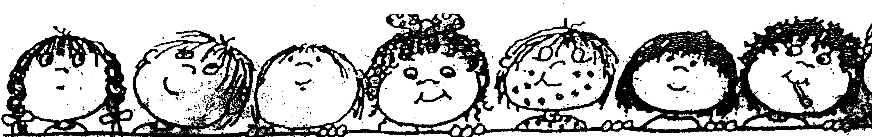

COMMUNICABLE DISEASES

Below you will find a list of common childhood illnesses and their symptoms.

DISEASES INCUBATION PERIOD SYMPTOMS

CHICKEN POX 10-21 days Blister-like eruptions, slight
Fever, cold symptoms

CONJUNCTIVITIS 2-5 days Redness of eye and a discharge
(PINK EYE) of pus from eyelids, matting
of eyes

FIFTH 4-14 days “Slapped cheek” rash on face,
DISEASE red rash on trunk & legs,
low-grade fever, malaise,
cold symptoms

H1N1 FLU 1-4 days Fever (possible), cough, sore throat, body aches, runny/
stuffy nose, headache, chills,
fatigue, diarrhea/vomiting
(sometimes)

HAND, FOOT, MOUTH 3-7 days Fever and blister-like eruptions
DISEASE (HFMD) in the mouth and/or a skin rash;
fever, poor appetite, sore throat

HEAD LICE 1-2 days Itching of scalp at nape of neck eggs (called nits) are stuck to hair

IMPETIGO 4-10 days Pustules, multiple weeping or
SCABIES crusted sores. Characteristic
burrow of the itch mite. Skin
may show scratch marks around
site

STREP INFECTION 1-3 days days Fever, headache, sore throat,
stomachache, “tonsillitis”, may
or may not have a rash.

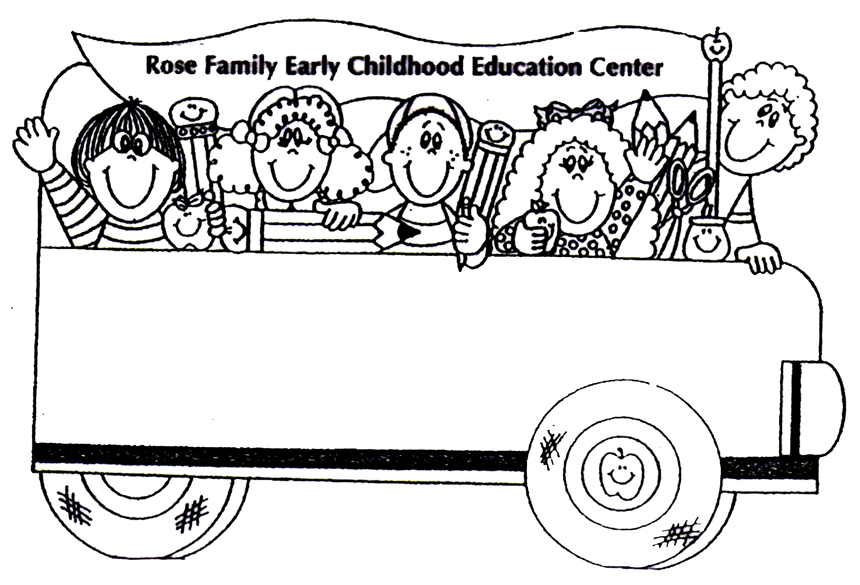
ARRIVAL & DEPARTURE

As a safety measure, we ask you to bring your child to their classroom each day, and pick them up in their classrooms after the teachers open the doors. Furthermore, we ask that you please arrive promptly at departure time. Not only might the teachers have other duties and responsibilities but also children begin to worry when that "familiar face" is not there. Arrival time is 9:00 for all classes. The toddler, mini-school and 3’s dismiss at 12:00. The Pre-K dismisses at 1:30 in the lower circle. We will bring the children out to your car. Stay & Play departs at 12:30, LB at 1:30 and ARF departs at 3:15. As a general policy, a late charge of $10.00 will be assessed for every 10 minutes late, beginning at dismissal time.


SCHOOL CLOSING POLICY

In anticipation of snowy weather during the school year, please remember our snow day policy. If Blue Valley District has a snow day, then we will as well.



EMERGENCY TREATMENT

Each child must have a current Consent for Emergency Treatment form on file in the school office before school begins. If there is a change in any of this information, please inform the office immediately.

DISCIPLINE

Teachers plan exciting, fun programs daily, based on the developmental level of the children, therefore eliminating most discipline problems before they begin. Furthermore, the teachers will use positive reinforcement in their guidance of appropriate behavior and will re-direct inappropriate behavior. Keeping the child happy and involved in age-appropriate activities reduces discipline problems and we encourage this!
PARKING AND SECURITY INFORMATION

PLEASE BE POLITE WHEN PARKING!! As we prepare for the beginning of the school year, we remind you to observe the various parking signs and markings around our building. It is critical for the security of our building, for the safety of our children, and for the necessary access to our entrance, that these designated areas be properly observed.

When picking up or dropping off your children at school, please park in the lot. Do not park in the circle drive (THIS IS A DROP OFF ZONE ONLY), along the islands or in spaces marked handicapped (unless you have the appropriate tags on your car). This blocks the flow of traffic and creates a hazard for children who are exiting the building. These areas cannot be blocked even for “a few minutes”. The Pre-K will dismiss at 1:30 in the lower circle. The teachers will bring the children out to their cars.

NEW BABY POLICY:* For the first month and a half of the baby’s life, you will be given a special parking pass to park at the end of the circle drive to bring in the older sibling.

HANDICAPPED AREAS** MUST BE LEFT FREE AND AVAILABLE FOR THOSE IN NEED OF THESE PARKING SPACES.

WHEELCHAIR-ACCESSIBLE CURBING MUST BE LEFT FREE AND UNBLOCKED.

PLEASE DO NOT PARK IN THE CROSSWALKS!
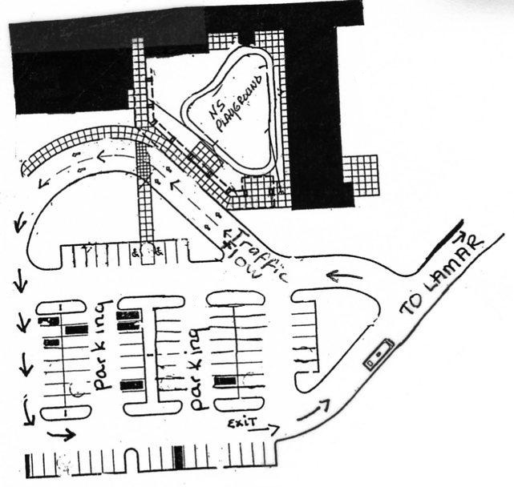
CAR SEAT REGULATIONS: Kansas law requires children ages 4 - 7 to be secured in a booster seat. Your child under age 1 should always ride in a rear-facing car seat. ... All children ages 4, 5, 6, and 7 are required to ride in a booster seat unless: The child weighs more than 80 pounds

CLOTHING

We do lots of messy things at school, so send
your child in clothes that you won't mind coming
home dirty. (Save the best clothes for special occasions.)

Because we try to develop self-reliance, try to
dress your child as simply as possible. Please try
to eliminate belts, suspenders, and any closure
that is hard to manipulate. This is especially
important for children who are recently toilet trained.

Please mark all outer wear, as many children wear
similar sweaters, hats, gloves, jackets, raincoats, etc.

When purchasing boots for rain or snow, please
get them plenty large and have them well marked.
If your child has shoe boots, please send regular
shoes with them in a sack. It gets so hot when boots
are worn all morning, and they do restrict the child's movement.

Be sure the shoes your child wears to school have
soles that do not slip. Sneakers are always preferred. Little girls' dress shoes and little boys'
cowboy boots are really cute, but they can be
dangerous when running over the waxed floors of
our classrooms as well as climbing and running outside.

Please do not send your child in
sandals or clogs as they are not made for climbing
and running. Also, check that shoe laces are not
too long.
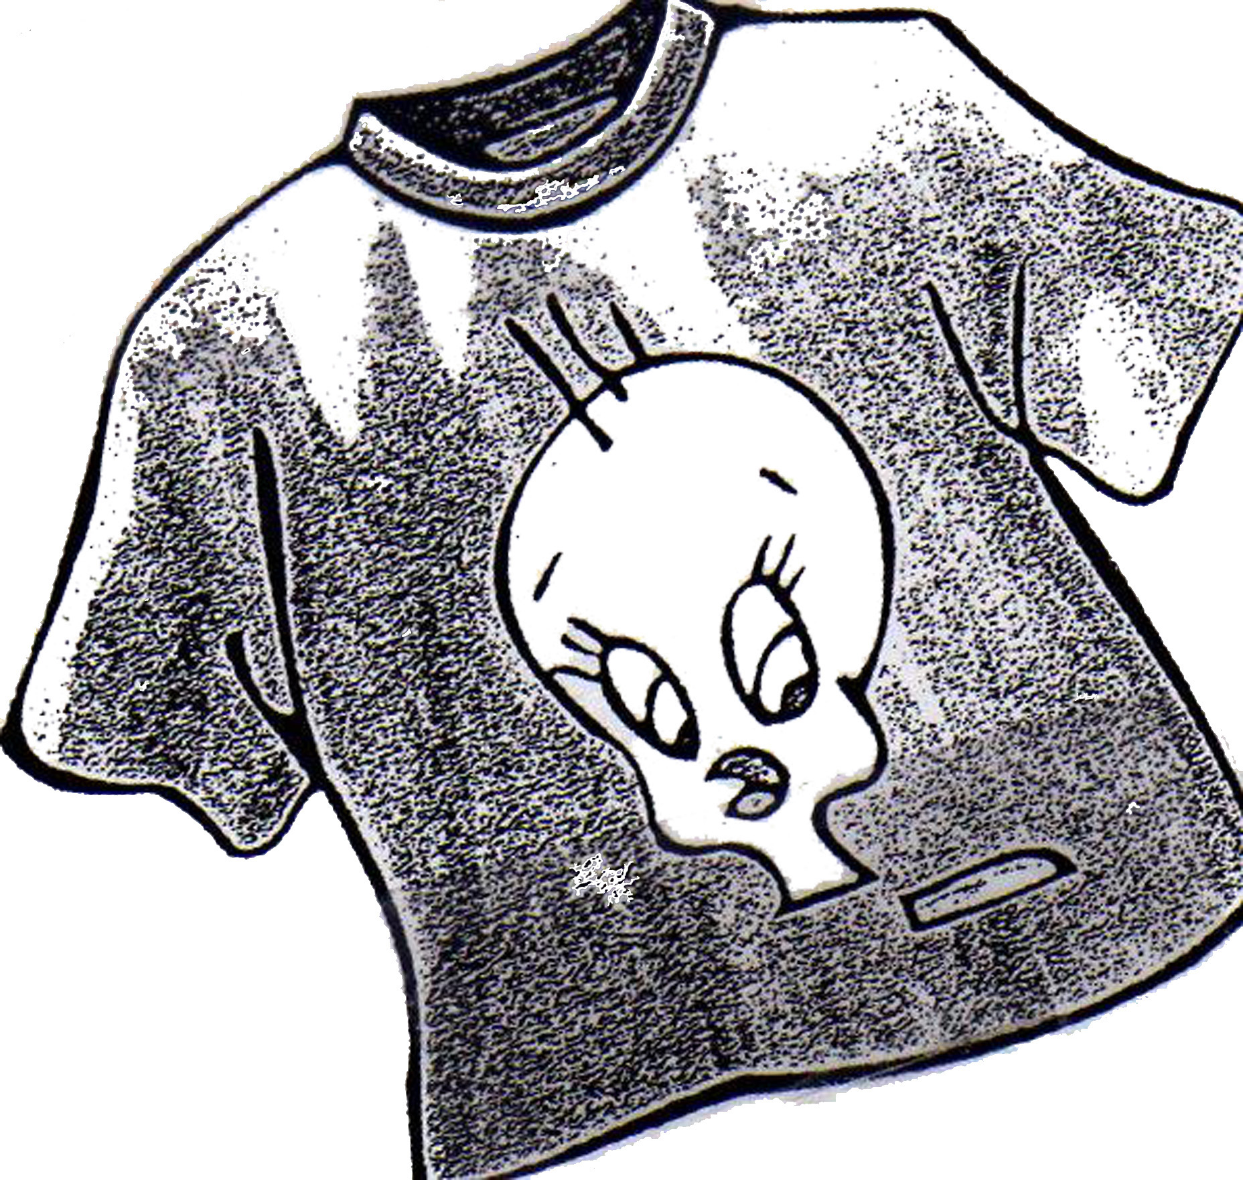
Remember: When the seasons change, please send in the
appropriate clothes for your child's
emergency "Spares".
“Dress for the Mess!”
BIRTHDAY PARTIES

Many of our families observe Shabbat. When planning private parties, please be considerate of these families and have the party on a day other than Shabbat (Friday evening & Saturday).

Your child is welcome to celebrate his/her birthday at school. Cakes, cupcakes, cookies, frozen yogurt or ice cream are welcome, but they must be from a certified kosher bakery or have a Kosher symbol on the box. Please do not buy products that say they may contain nut products or have been manufactured in a plant that may have processed nut products. Please prearrange parties with your child's teacher.

Certified kosher bakeries are: Hen House Bakery (117th & Roe only) and Bagel Works (bread & bagels only).

Acceptable ice cream products are: T.C.B.Y. (check for kashrut reliability of toppings, cake, and decorations), Baskin Robbins (most flavors, check if there is a question), Edy's, Blue Bunny, and several other national brands. Look for Kosher symbols on the container.

Pre-packaged products are acceptable if they are imprinted with one of the acceptable kosher symbols:

Products bearing one of the following symbols may be used without further inquiry.
Any product-that requires supervision-bearing a symbol other than the ones listed below may NOT be used until approved by the Vaad.

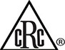






Orthodox Union Organized Kashruth Chicago Rabbinical Council Kof-K Star-K Star-K Dairy Vaad Hoeir St. Louis Texas K (cRc)



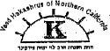

Igud Hakashrus, Kehilla Kosher Kosher Supervision of America Rabbinical Council California Vaad of Northern California Scroll K, Denver


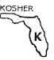





Kosher Miami Florida K Atlanta Kashrus Indianapolis Vaad of New England Diamond K KC Vaad


United Mehadrin Blue Ribbon (cRc) Hisachdus Crown Heights Kahal Adath Jeshurun Cleveland






South Palm Beach Florida Buffalo Council of Orthodox Rabbis Detroit Dallas Houston





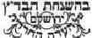


Chabad Guadaljara Mexico Earth Kosher Singapore Beis Din Tzedek of the Beis Din Tzedek of Agudas Israel
Eidah Hachareidis of Jerusalem Moetzes Hakashrus








British Columbia Australia Montreal Vaad Hoeir Kashrus Council Canada London Beis Din

Remember: Beth Shalom Rose Family Early Childhood Education is a nut free school.

If your child is having a private birthday party outside of the school, please do not pass out invitations at school or put them in the children’s cubbies. We ask that you mail invitations so that no feelings will be hurt. Also, it is a big treat for a child to get his or her “own mail”.

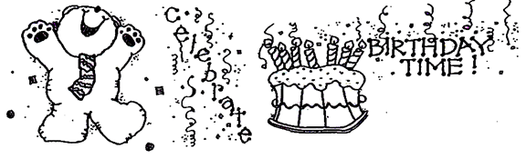
Non Meat Lunch Ideas

1. Egg Salad 32. Thick vegetable soups (Thermos)
2. Grilled Cheese 33. Fruit salad
3. Tortilla Wrap 34. Hummus
4. Hard Boiled Egg whole or sliced 35. Guacamole & Chips
5. Cheese and Crackers 36. Graham Crackers & Cream Cheese
6. Cream Cheese and Jelly 37. String Cheese
7. Morning Star Farms 38. Soy Butter & Jelly Sandwich
Veggie/Soy Corndogs, hot dogs, 39. Smoothie (in a Thermos)
chicken nuggets, etc… 40. Tuna Noodle Casserole
8. Cottage Cheese and Fruit 41. Soy Spaghetti
9. English Muffin Tuna Melt, 42. Noodle Kugel
pizza, melted cheese 43. Pasta Salad
10. Yogurt 44. Deviled Eggs
11. Fish Sticks 45. Potato/Veggie Latkes
12. Falafel Balls 46. Matzah & Cheese Latkes/Pancakes
13. Salmon Patty 47. Veggie or Soy Lasagna
14. Tuna Muffins
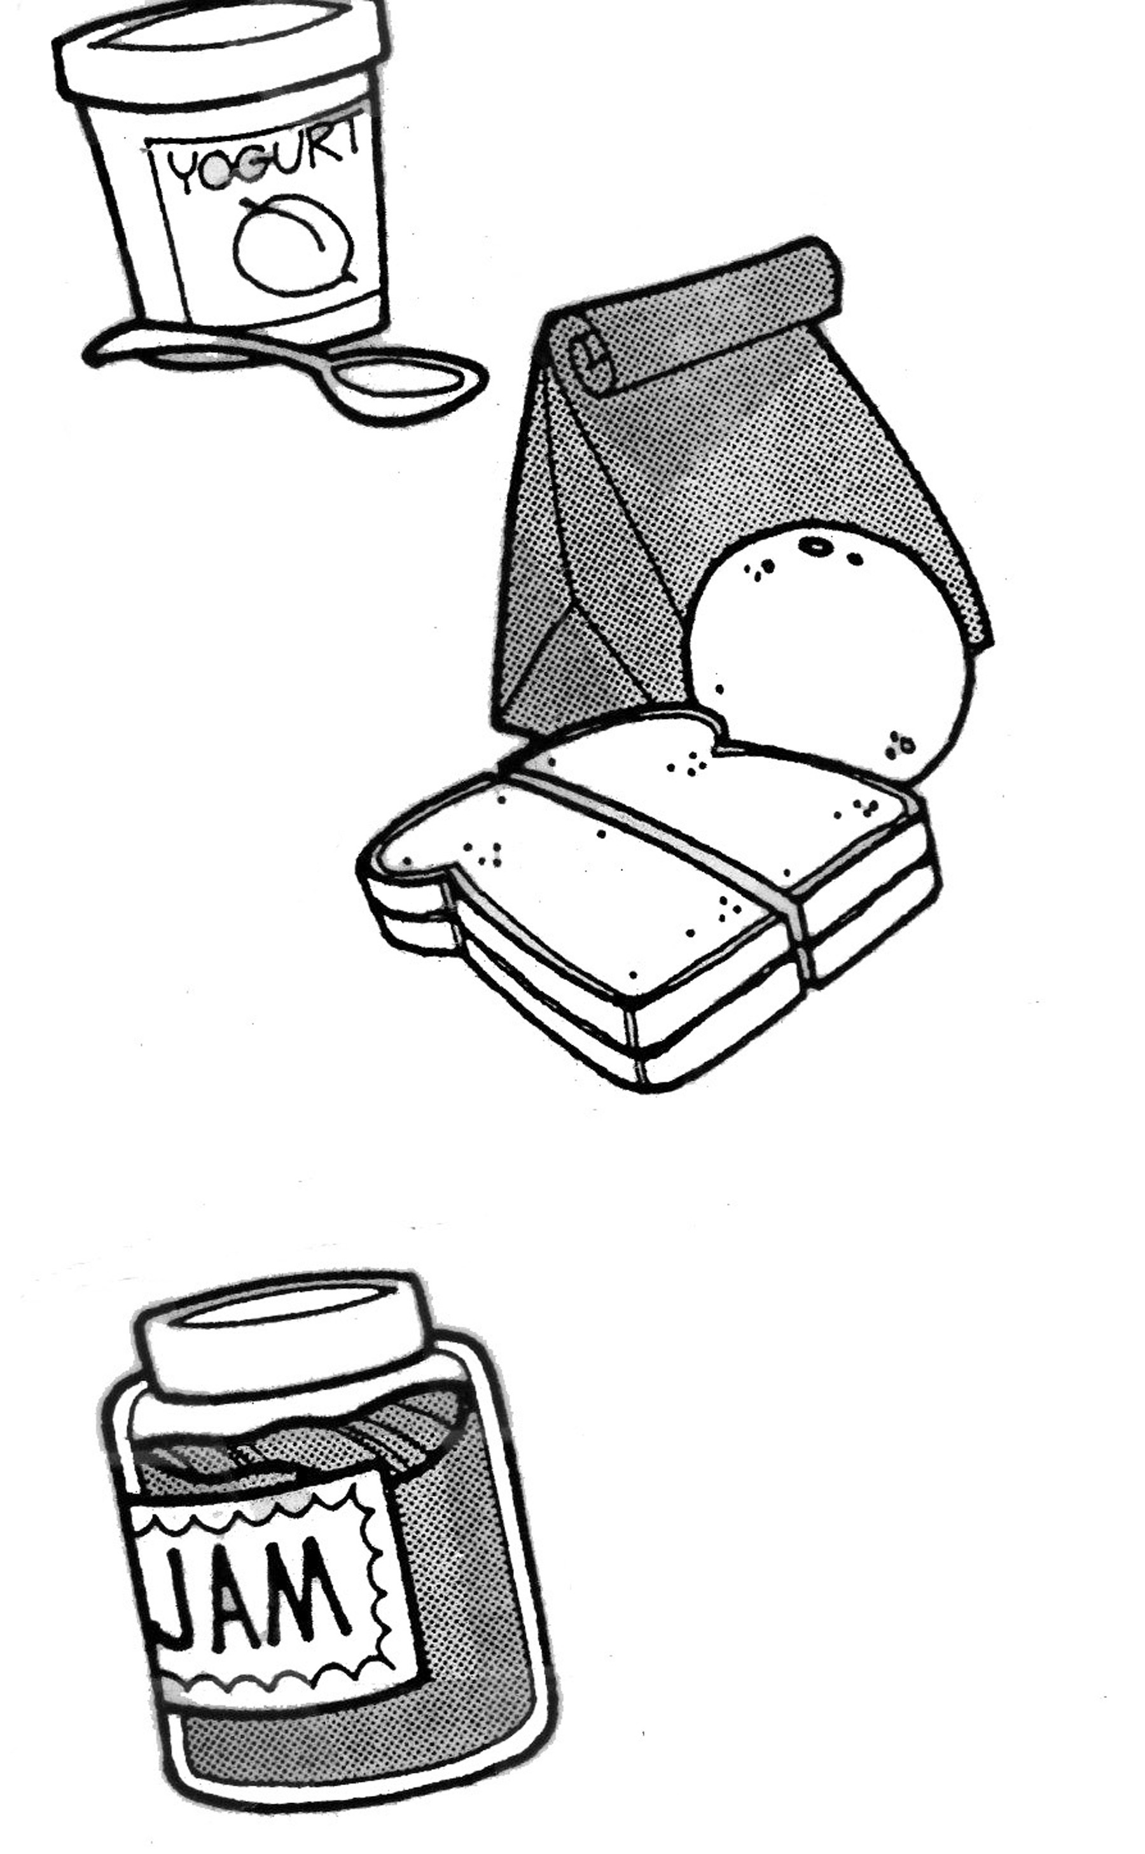
15. Quiche
16. Cheese Pizza
17. Mac and Cheese
18. Cheese (Spread) and Cracker
19. Veggie/Soy Burger
20. Crescent Rolls with Cheese Rolled Up
21. Biscuit Egg and Cheese
22. Gefilte Fish
23. Bagel, Cream Cheese and Lox24. Bagel and Tuna
25. Bagel and Cheese Slices
26. Granola Bars
27. Buttered Noodles with Parmesan Cheese
28. Pasta with Vegetarian Sauce
29. Quesadillas w/ cheese, rice etc…
30. Tuna Fish & Crackers
31. Vegetarian Chili w/ chips

