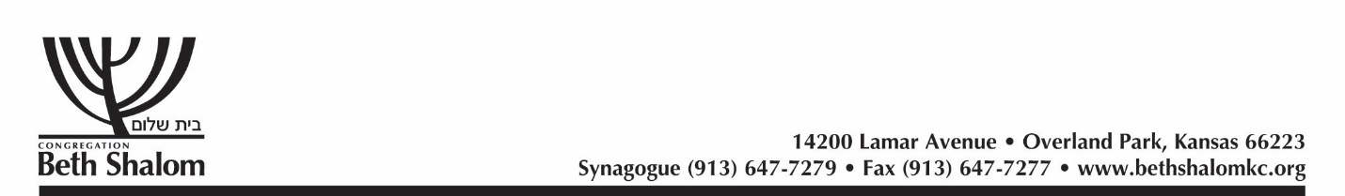

2020 APPLICATION FOR SCHOLARSHIP
SUMMER CAMP & ISRAEL PROGRAMS

DATE OF APPLICATION
Dear Parent and Scholarship Applicant:
One of the most beautiful aspects of Beth Shalom Synagogue is the continued provision by many of its members for future generations. Contributions made for the benefit of our youth are accumulated in the Permanent Scholarship Fund, and the income from the invested fund is available for scholarships. These scholarships are allocated in the form of grants, and are given on the basis of financial need.
Please read this application thoroughly. It must be filled out COMPLETELY and signed by a parent. No application can be considered if not completed in full. All matters pertaining to scholarship applications will be held in strictest confidence.
Each family must pay a portion of the camp tuition fees, and is fully responsible for other camp-related costs.
Please return the completed application to the PRS School Office (Attn: Richard Simon)
14200 Lamar, OPKS 66223
By FRIDAY, March 2nd, 2020
Name Of Parent(s)
Home Address:
City, State, Zip
Phone Number (Home):
Phone Number (Work):
E-Mail Address:

Name of Child(ren) applying for Scholarship(s) | Relationship | Age | Grade

PARENT INFORMATION
NO APPLICATION WILL BE CONSIDERED UNLESS ALL ITEMS HAVE BEEN COMPLETED. WHEN AN ITEM DOES NOT APPLY, PLEASE PRINT "DOES NOT APPLY".
Father’s Name:
Home Address (*if different from page 1):
Home Phone: (*if different from page 1):
Name of Employer:
Business Address:
Business Phone:
Nature of Business or Profession:
Position held:
Years with Firm:

Mother’s Name:
Home Address (*if different from page 1):
Home Phone: (*if different from page 1):
Name of Employer:
Business Address:
Business Phone:
Nature of Business or Profession:
Position held:
Years with Firm:

Annual Income
Earned Income – Husband: | $
Wife: | $
Interest & Dividends: | $
Other Income: | $
Total Income (from Form 1040) | $
In order for your application to be complete, you must attach a copy of your most recent Form 1040 Tax Return.
1. During the last four years, have any children in the family received, or are they now receiving any scholarship aid whatsoever? Yes No .
If yes, please give full details including the dollar amount of aid and person or institution granting the scholarship.

2. Please list any other persons receiving financial support from the family.
Name Age
Relation to Applicant
Amount of total annual support from the family $

3. Total amount of financial aid from other sources received for the other children $

4. Please indicate if your child is eligible for the first-time camper grant. Yes No .
Have you applied for this grant? Yes No .
Please list amount received $ .
5. Please explain in detail the circumstances of which the Committee should be aware in considering your application

Signature of Parent or Guardian

Signature Date
Complete one sheet for each child.
THIS APPLICATION CANNOT BE PROCESSED UNLESS THIS SECTION IS COMPLETED IN FULL—INCLUDING THE AMOUNT YOU ARE REQUESTING***
Child’s Name:
Age of Child
Does your child attend Polsky Religious School or Hyman Brand Hebrew Academy? Indicate which one:
Name of Camp or Israel Program:
Date of Program:
Length of Program (weeks):
Total Cost of Program: |  | $
Amount paid by Family: |  | $
Amount of Scholarship Request:*** |  | $
Have you applied for scholarship assistance to any other organization(s)? YES NO
(Please also consider assistance from the Guardian Society via the KC Jewish Federation
https://www.jewishkansascity.org/get-involved/young-adults/scholarships-incentives/jewish-camp-grants)
If yes, which organization(s)?
Is this child a first-time camper? Yes ______ No: _______
STUDENT ESSAY (50 words or less) ON THE SUBJECT
“WHY I WOULD LIKE TO ATTEND THIS PROGRAM”
(Only for children over 7 years old)

Complete one sheet for each child.
THIS APPLICATION CANNOT BE PROCESSED UNLESS THIS SECTION IS COMPLETED IN FULL—INCLUDING THE AMOUNT YOU ARE REQUESTING***
Child’s Name:
Age of Child
Does your child attend Polsky Religious School or Hyman Brand Hebrew Academy? Indicate which one:
Name of Camp or Israel Program:
Date of Program:
Length of Program (weeks):
Total Cost of Program: |  | $
Amount paid by Family: |  | $
Amount of Scholarship Request:*** |  | $
Have you applied for scholarship assistance to any other organization(s)? YES NO
(Please also consider assistance from the Guardian Society via the KC Jewish Federation
https://www.jewishkansascity.org/get-involved/young-adults/scholarships-incentives/jewish-camp-grants)
If yes, which organization(s)?
Is this child a first-time camper? Yes ______ No: _______
STUDENT ESSAY (50 words or less) ON THE SUBJECT
“WHY I WOULD LIKE TO ATTEND THIS PROGRAM”
(Only for children over 7 years old)

